**Case Study 2**

* Includes view table and derived table with dimensions and measures.
* Includes Screenshots of Dashboard and looks visualizations.

--------------------------------------------------------------------------------------------------------------------------

**# The name of this view in Looker is "Orders Vw"**

view: orders_vw {

# The sql_table_name parameter indicates the underlying database table

# to be used for all fields in this view.

sql_table_name: `poc-analytics-ai.sample_superstore.orders_vw` ;;

drill_fields: [order_item_id]

# This primary key is the unique key for this table in the underlying database.

# You need to define a primary key in a view in order to join to other views.

dimension: order_item_id {

primary_key: yes

type: number

sql: ${TABLE}.id ;;

}

# Dates and timestamps can be represented in Looker using a dimension group of type: time.

# Looker converts dates and timestamps to the specified timeframes within the dimension group.

dimension_group: created {

type: time

timeframes: [

raw,

time,

date,

week,

month,

quarter,

year

]

sql: ${TABLE}.created_at ;;

datatype: date

}

# Here's what a typical dimension looks like in LookML.

# A dimension is a groupable field that can be used to filter query results.

# This dimension will be called "Delivered At" in Explore.

dimension: delivered_at {

type: string

sql: ${TABLE}.delivered_at ;;

}

dimension: inventory_item_id {

type: number

sql: ${TABLE}.inventory_item_id ;;

}

dimension: order_id {

type: number

sql: ${TABLE}.order_id ;;

}

dimension: returned_at {

type: string

sql: ${TABLE}.returned_at ;;

}

dimension: sale_price {

type: number

sql: ${TABLE}.sale_price ;;

}

# A measure is a field that uses a SQL aggregate function. Here are defined sum and average

# measures for this dimension, but you can also add measures of many different aggregates.

# Click on the type parameter to see all the options in the Quick Help panel on the right.

measure: total_sale_price {

type: sum

sql: ${sale_price} ;;

}

measure: average_sale_price {

type: average

sql: ${sale_price} ;;

}

dimension: shipped_at {

type: string

sql: ${TABLE}.shipped_at ;;

}

dimension: status {

type: string

sql: ${TABLE}.status ;;

}

dimension: user_id {

type: number

sql: ${TABLE}.user_id ;;

}

measure: count {

type: count

drill_fields: [order_item_id]

}

#####################################################################################

------------------------------------------------------------------------------------------------------------------

#Total Lifetime Orders

#The total number of orders placed over the course of customers’ lifetimes.

measure : total_life_time_orders{

type :sum

sql: ${order_item_id} ;;

}

-------------------------------------------------------------------------------------------------------------------------------------------------------

#Total Lifetime Revenue

#The total amount of revenue brought in over the course of customers’ lifetimes.

measure: total_lifetime_revenue {

type: sum

value_format_name: usd

sql: ${sale_price} ;;

}

---------------------------------------------------------------------------------------------------------------------

#First Order Date

#The date in which a customer placed his or her first order on the fashion.ly website

measure: first_order_date{

type: date

sql: MIN(${created_date}) ;;

}

----------------------------------------------------------------------------------------------------------------------

#Latest Order Date

#The date in which a customer placed his or her most recent order on the fashion.ly website

measure: latest_order_date{

type: date

sql: MAX(${created_date}) ;;

}

----------------------------------------------------------------------------------------------------------------------

#Is Active

#Identifies whether a customer is active or not (has purchased from the website within the last 90 days)

measure: is_active{

type: yesno

sql: DATE_DIFF(CURRENT_DATE(),DATE(${latest_order_date}),DAY)<=90 ;;

}

---------------------------------------------------------------------------------------------------------------------

#Average Days Since Latest Order

#The average number of days since customers have placed their most recent orders on the websit

measure: days_since_latest_order{

type: number

sql: DATE_DIFF(CURRENT_DATE(),DATE(${latest_order_date}),DAY);;

}

--------------------------------------------------------------------------------------------------------------------------

#Repeat Customer

#Identifies whether a customer was a repeat customer or not

measure: order_count {

type: count_distinct

sql: ${order_id} ;;

}

measure: repeat_customer{

type: yesno

sql: ${order_count}>1 ;;

# COUNT(${order_id} > 1) ;;

}

}

---------------------------------------------------------------------------------------------------------------------------------

------------------------------------------derived_table--------------------------------------------------------------------------

---------------------------------------------------------------------------------------------------------------------------------

view: derivedn_order {

derived_table: {

explore_source: orders_vw {

column: days_since_latest_order {}

column: order_count {}

column: total_lifetime_revenue {}

column: user_id {}

}

}

-----------------------------------------------------------------------------------------------------------------------

#Days Since Latest Order

#The number of days since a customer placed his or her most recent order on the website

measure: days_since_latest_order {

description: ""

type: average

}

--------------------------------------------------------------------------------------------------------------------

#Average Lifetime Orders

#The average number of orders that a customer places over the course of their lifetime as a customer.

measure: order_count {

description: ""

type: average

}

---------------------------------------------------------------------------------------------------------------------

#Average Lifetime Revenue

#The average amount of revenue that a customer brings in over the course of their lifetime as a customer.

measure: total_lifetime_revenue {

description: ""

value_format: "$#,##0.00"

type: average

}

dimension: user_id {

description: ""

type: number

primary_key: yes

}

------------------------------------------------------------------------------------------------------------------------------------------

#Customer Lifetime Revenue

#The total amount of revenue brought in from an individual customer over the course of their patronage. Lifetime revenue is often analyzed based on specific value groupings. These groupings are:

#$0.00 - $4.99

#$5.00 - $19.99

#$20.00 - $49.99

#$50.00 - $99.99

#$100.00 - $499.99

#$500.00 - $999.99

#$1000.00 +

dimension: customer_lifetime_revenue {

type: tier

tiers: [0.00, 5.00, 20.00, 50.00, 100.00, 500.00, 1000.00]

style: relational

value_format_name: usd

sql: ${TABLE}.total_lifetime_revenue ;;

}

------------------------------------------------------------------------------------------------------------------------------------------

# Customer Lifetime Orders

#The total number of orders that a customer has placed since first using the website. Customers are typically analyzed in groupings rather than by the specific number of orders placed. These groupings are:

#1 Order

#2 Orders

#3-5 Orders

#6-9 Orders

#10+ Orders

dimension: customer_lifetime_orders {

type: tier

tiers: [1, 2, 3, 6, 10]

style: integer

#sql: ${order_id};;

sql: ${TABLE}.order_count ;;

}

}

**Visualizations of this case study**

1. **Dashboard**

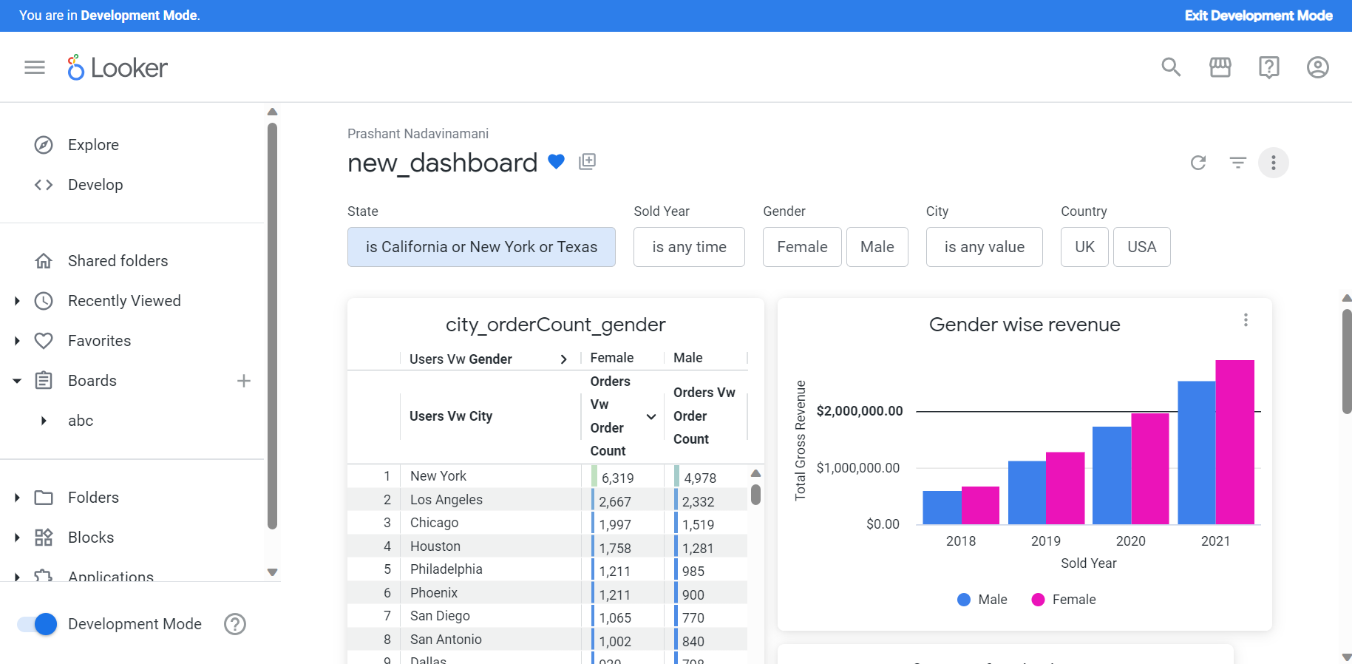

**2)** city_orderCount_gender

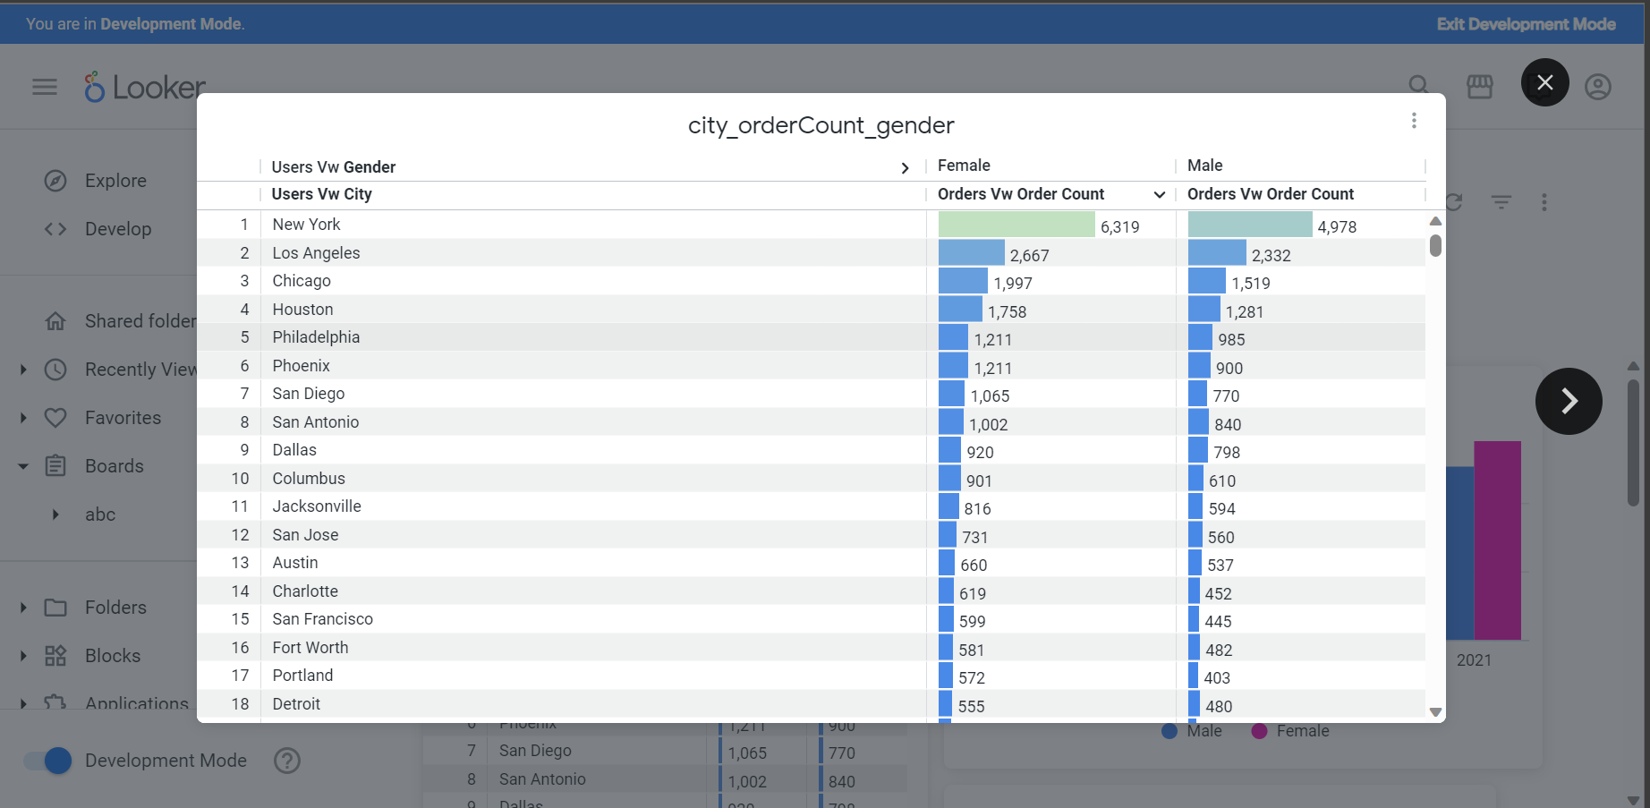

3)Gender wise revenue

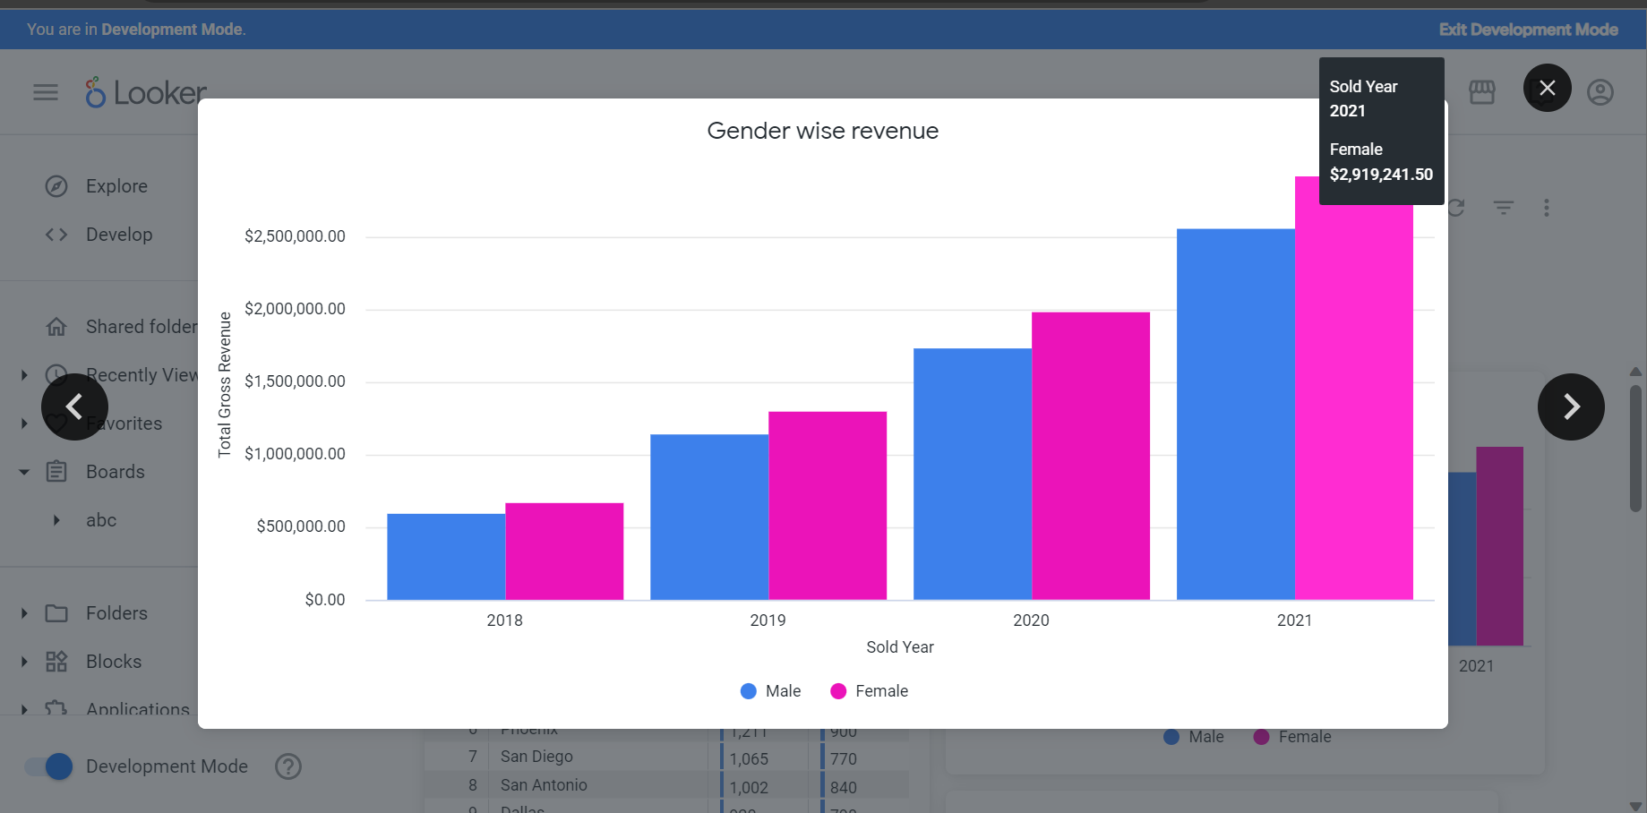

4) total gross revenue v/s status

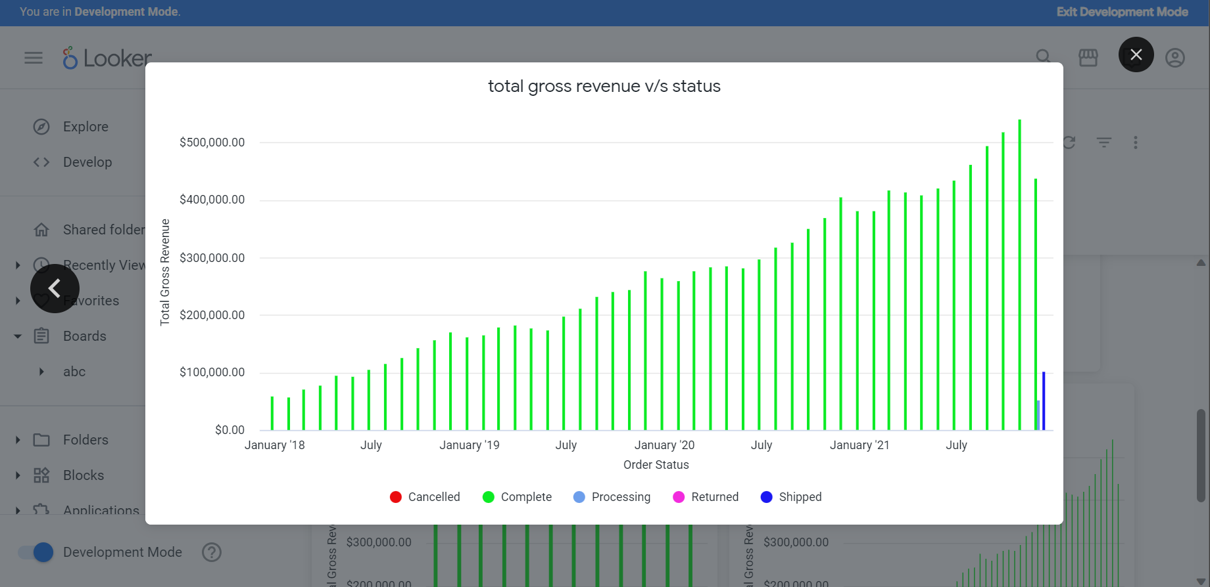

5) Status of order items based on city

